logo

Project Name – PR#00000

Project Title
Lite Requirements Document

Version 1.0
Last Updated: 26 July 2017
Author: Firstname Lastname
Document Classification: Internal Document

v 1.3

Requirements for <project title>

Questions About This Document | Questions about this document can be referred to the Requirements Manager:

Name | Phone # | Email Address
Firstname Lastname | 123-456-7890 | email@domain.tld

Change / Revision History
Date | Version | Name of Person Making Change | Description of Changes | Pages/Sections Affected

Table of Contents
1.0 Purpose of this Document 4
2.0 Business Overview 4
3.0 Initiative Overview 4
3.1 Scope 4
3.x Out of Scope 4
3.2 Assumptions & Dependencies 4
3.3 Constraints 4
4.0 Requirements 4
4.1 Business Requirements 4
4.2 Non-Functional Requirements 4
4.3 Requirements Considered 4
5.0 Security Requirements 4
6.0 Appendix 5
6.1 Version Control 5
6.2 Glossary 6
Stakeholders

Participating Business Units | The following business units are participating/sponsoring this initiative:

Business Unit / Department | Name & Title | Role / Responsibility

Sources of Requirements | The following individuals were a source of requirements for this document:

Business Unit / Department | Name & Title | Role / Responsibility

Reviewers of Requirements | The following individuals were invited to review this document, and provide feedback:

Business Unit / Department | Name & Title | Date

Document Approvals

Concurred By | The following individuals have signed off on this document:

Business Unit / Department | Name & Title | Signature | Date
 |  |  | 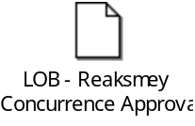
 |  |  | 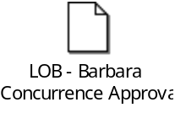
 |  |  | 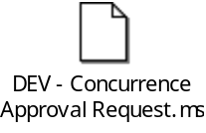
 |  |  | 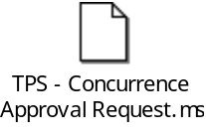
 |  |  | 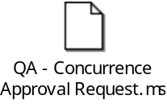
 |  |  | 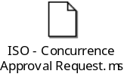
 |  |  | 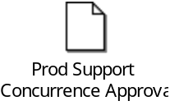

Approved By | The following individuals have signed off on this document:

Business Unit / Department | Name & Title | Signature | Date

Purpose of this Document

The purpose of this document is to highlight the requirements for <project name>.

Business Overview
Business description of products/services project will impact.

Initiative Overview
Technical description of products/services project will impact.

Scope

List of items in scope for the project.

3.x Out of Scope

List of items out of scope for the project.

Assumptions & Dependencies
List of all assumptions & dependencies for the project.

Constraints

List of constraints for the project.

Requirements

Business Requirements
List of business requirements for project.

Non-Functional Requirements
List of non-functional requirements for project.

Requirements Considered
The following categories of non-functional requirements were considered for this initiative, but deemed not applicable:

Requirement Category | Reason Not Applicable

Security Requirements
# | Scope Area | Requirement Grouping | Requirement Description | Detail Level | Reference
5.0.01 | Software Development | General | The source code of all applications must be analyzed for security defects. | High
5.0.01.1 | Software Development | General | Application must properly protect shared variables and resources from inappropriate concurrent access. | Detail
5.0.01.2 | Software Development | General | Integrity of open source code must be verified using checksums or hashes when downloaded. | Detail
5.1.01 | Software Development | Secure Coding | End users must not be permitted to access object references directly. | High
5.1.01.1 | Software Development | Secure Coding | Developers must not expose a reference to an internal implementation object, such as a file, directory, database record, or key, as a URL or form parameter to users. | Detail
5.1.02 | Software Development | Secure Coding | All user inputs must be validated to avoid security issues (e.g. cross-site scripting, SQL injection, etc.). | High
5.1.02.1 | Software Development | Secure Coding | Data from client side, either modified or new, should be treated as externally inputted and validated on server side. | Detail
5.1.03.2 | Software Development | Secure Coding | All input validation must be performed on server side even if validations are performed before on client side to provide better end user experience, for example, Ajax based pages. | Detail
5.1.02.3 | Software Development | Secure Coding | A positive validation pattern must be defined and applied to all input. | Detail
5.1.02.4 | Software Development | Secure Coding | All input validation failures must result in input rejection or input sanitization. | Detail
5.1.02.5 | Software Development | Secure Coding | All input validation failures on the server side must be logged in audit log files. Input validation failures on client side that need to be logged must also be logged to the server. | Detail
5.1.02.6 | Software Development | Secure Coding | A character set, such as UTF-8, must be specified for all sources of input. | Detail
5.1.02.7 | Software Development | Secure Coding | A centralized input validation control must be used by the application for each type of data that is accepted. | Detail
5.1.03 | Software Development | Secure Coding | All outputs to user must be validated to avoid security issues (e.g. malicious links, sensitive data, etc.). | High
5.1.03.1 | Software Development | Secure Coding | All output encoding/escaping controls must be implemented on the server side. | Detail
5.1.03.2 | Software Development | Secure Coding | All untrusted data that are output to any interpreters must be escaped properly. SQL interpreters must use parameterized interfaces, prepared statements, or are escaped properly. XML must use parameterized interfaces or are escaped properly. LDAP queries and operating system command parameters must be escaped properly. | Detail
5.1.03.3 | Software Development | Secure Coding | For each type of output encoding/escaping performed by the application, there must be only a centralized security control for that type of output for the intended destination. | Detail
5.1.04 | Software Development | Secure Coding | The system must include effective error handling logic to prevent data leakage. | High
5.1.04.1 | Software Development | Secure Coding | Information resource (system, application, and database) must not output error messages or stack traces containing sensitive data that could assist an attacker, including session id and personal information. | Detail
5.1.04.2 | Software Development | Secure Coding | All server side errors must be handled on the server itself. | Detail

Appendix

6.1 Version Control
Date | Author | Ver | Change
YYYY-MM-DD |  |  | UID | Description
2017 – 07-20 | Maria Vlad | 1.0 |  | Updated ‘Concurred By’ section with received concurrences.
2017 – 27- 20 | Maria Vlad | 1.0 |  | Updated as per Dan/LOB’s request:  - Added benefits of WAS and Jasper Upgrades  - Replace ‘should’ with ‘must’ to clarify that WAS and Jasper must not impact current services.

6.2 Glossary
Term | Definition

